**Project Management Plan**

**Course**: MIS 697 – Project Planning and Management  
**Assignment**: Project Management Plan  
**Team**: Intelligent Iguanas  
**Project Title**: Queue-Free: The Future of Fast Concession Stands  
**Consulting Firm**: Plan365  
**Submission Date**: 5/14/2025  
**Word Count**: [2882]

Contents

1. Executive Summary 2

2. Introduction 2

3. Project Stakeholders and Organization 3

3.1 Internal Stakeholders 3

3.2 External Stakeholders 3

4. Project Governance and Roles 4

4.1 Governance Structure 4

4.2 Key Roles and Responsibilities 4

5. Project Objectives, Deliverables, and Scope 5

5.1 Objective Overview 5

5.2 Key Deliverables 6

5.3 Scope Statement 6

6. Project Schedule and Work Breakdown Structure (Expanded) 7

6.1 Project Timeline & Phases 7

6.2 Work Breakdown Structure (WBS) and Gantt Chart 8

7. Budget 8

7.1 Budget Strategy 8

7.2 Detailed Budget Table 8

7.3 Summary Budget Breakdown 9

7.4 Budget Notes 9

8. Risk Management 9

8.1 Risk Categories & Examples 10

8.2 Risk Matrix and Response Plan 10

9. Quality Management 10

9.1 Quality Goals 10

9.2 Quality Assurance Activities 11

10. Procurement Management 11

11. Configuration Management 11

11.1 Overview 11

11.2 Change Control Board 12

12. Monitoring, Reporting, and Communication 12

12.1 Reporting Schedule 12

12.2 Tools Used 12

13. Conclusion 13

14. References 13

15. Appendix 13

15.1 RACI Matrix 13

15.2 Selection Matrix (Digital Platform Options) 14

# 1. Executive Summary

The *Queue-Free* Project Management Plan outlines the strategic transformation of concession stand operations at **SDSU’s Viejas Arena** through the adoption of modern digital technologies. The current state of operations is characterized by outdated, manually intensive workflows, which contribute to long lines, slow service, and limited transaction capacity during peak periods such as athletic events and concerts. These issues not only affect customer satisfaction but also limit potential revenue and create operational inefficiencies.

This initiative introduces a **three-tiered digital solution**: (1) a mobile ordering platform to allow pre-ordering and cashless payments, (2) a real-time **RFID-based inventory management system** to eliminate stock-outs and reduce spoilage, and (3) upgraded **Point-of-Sale (POS) terminals** to accelerate transaction speed and reliability.

The project adopts a structured project management framework that includes:

* Stakeholder identification and active engagement strategies
* A clearly defined scope and Work Breakdown Structure (WBS)
* A granular, category-based budget plan
* A communication matrix tailored to each stakeholder group
* Risk analysis and contingency strategies to maintain control under uncertainty
* Quality assurance checkpoints and post-implementation KPIs

By focusing on **speed, transparency, and user experience**, Queue-Free not only seeks to modernize the concessions infrastructure but also serves as a model for university-wide digital transformation initiatives. The project is designed to go live in **August 2025**, aligning with the fall athletic season, ensuring the solution is stress-tested in a live, high-demand environment.

# 2. Introduction

**Organization:** SDSU Concessions  
**Project Title:** Queue-Free: The Future of Fast Concession Stands  
**Consulting Partner:** Plan365

**Context and Rationale**

Concession stands at **Viejas Arena** face several systemic challenges that impede operational performance:

* Long queues due to inefficient order-taking and cash handling
* Inventory mismanagement that leads to overstocking or stockouts during key events
* Minimal data tracking, making it hard to adjust staffing, inventory, or pricing dynamically

These inefficiencies directly impact **customer experience**, **sales potential**, and **resource optimization**. As SDSU positions itself as a leader in campus digital transformation, the Queue-Free initiative serves as a pilot for integrating technology into high-traffic, service-based environments.

The university's broader strategic goals—including enhancing student and community engagement, improving operational sustainability, and leveraging data for continuous improvement—align with the objectives of this project.

**Business Drivers and KPIs**

| **Driver** | **Target Metric** | **Justification** |
| --- | --- | --- |
| Reduce customer wait times | < 5 minutes (50% reduction) | Long lines deter purchases and frustrate attendees |
| Increase sales per event | 25–30% growth in average order count | Faster transactions = more purchases within fixed intermissions |
| Improve inventory control | 15% reduction in overstock/waste | Real-time RFID tracking reduces spoilage and improves forecasting |
| Elevate user experience | App satisfaction rating > 4.5/5 | Mobile UX enables better planning and user retention |
| Lower operational errors | 0–2% discrepancy in inventory post-launch | Automation replaces manual counting and cashier input errors |

# 3. Project Stakeholders and Organization

Stakeholders are categorized based on their roles in **project execution**, **decision-making**, or **influence**. Understanding their needs and impact levels is essential for communication and risk mitigation.

## 3.1 Internal Stakeholders

| **Stakeholder** | **Role** | **Responsibility** | **Interest Level** |
| --- | --- | --- | --- |
| SDSU Concessions Dept. | Project Owner | Funding, operations coordination, post-launch management | High |
| Gordon Otto (Exec. Sponsor) | Strategic Oversight | Resource approval, governance, risk management | High |
| Project Team (Intelligent Iguanas) | Planning & Implementation Team | Designing, building, executing all project elements | High |
| Concession Stand Manager | Operational Lead | Daily implementation, managing staff and systems post-launch | High |

## 3.2 External Stakeholders

| **Stakeholder** | **Role** | **Responsibility** | **Engagement Type** |
| --- | --- | --- | --- |
| Event Attendees | End Users | Use mobile app, provide feedback | Indirect |
| Health Department | Regulator | Ensure food safety and tech hygiene compliance | Consulted |
| Technology Vendors | Infrastructure Providers | Supply POS, RFID, software | Contracted |
| SDSU Athletics | Facilities & Experience Manager | Coordination for game-day implementation | Consulted |

# 4. Project Governance and Roles

Project governance outlines the hierarchy, responsibilities, and coordination mechanisms that support decision-making and control.

## 4.1 Governance Structure

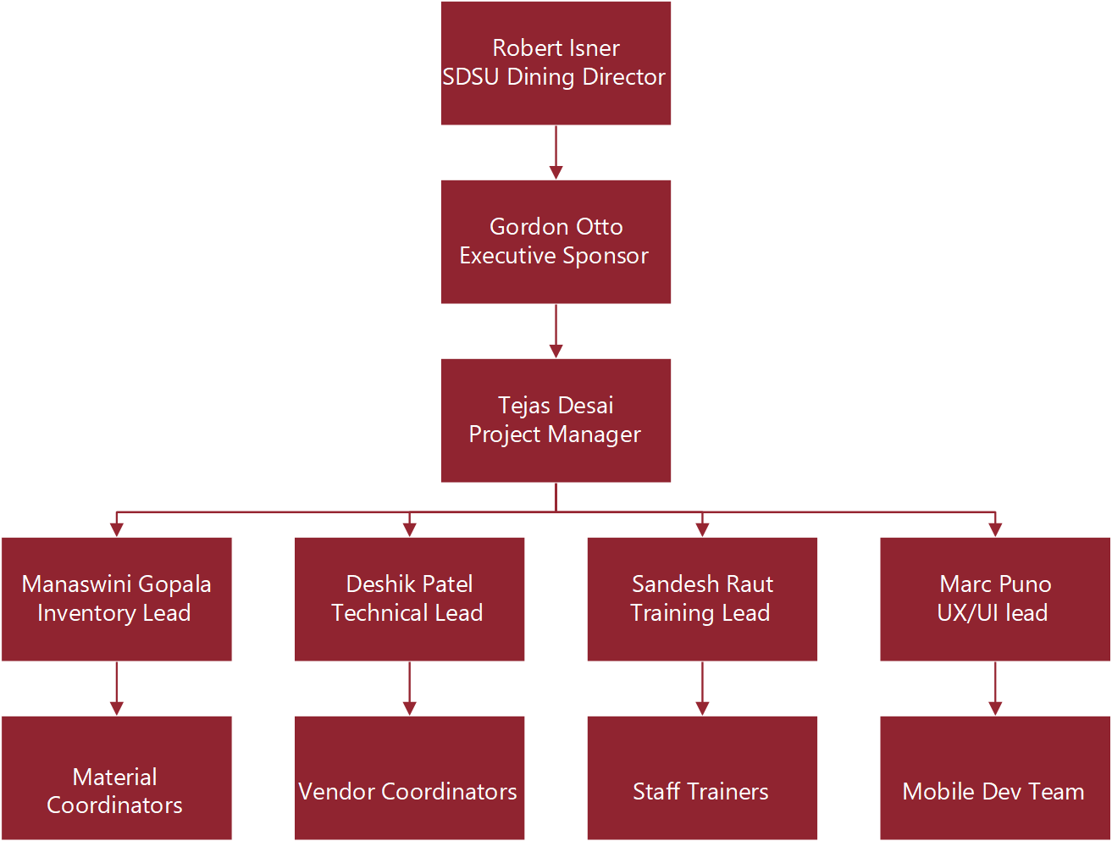

## 4.2 Key Roles and Responsibilities

| **Role** | **Person(s) Assigned** | **Key Responsibilities** |
| --- | --- | --- |
| Executive Sponsor | Gordon Otto | Strategic approval, escalations, final go-live sign-off |
| Project Manager | Tejas Desai | Overall leadership, scope, time, cost, and stakeholder coordination |
| Technical Lead | Deshik Patel | POS installation, RFID backend, app integration |
| Inventory Lead | Manaswini Gopala | RFID logistics, software configuration, inventory testing |
| UX/UI Lead | Marc Puno | User interface design for mobile ordering and customer flow |
| Training Lead | Sandesh Raut | Staff onboarding, training materials, performance tracking |
| Vendor Manager | Shared | Vendor contracts, quality monitoring, and deployment |

# 5. Project Objectives, Deliverables, and Scope

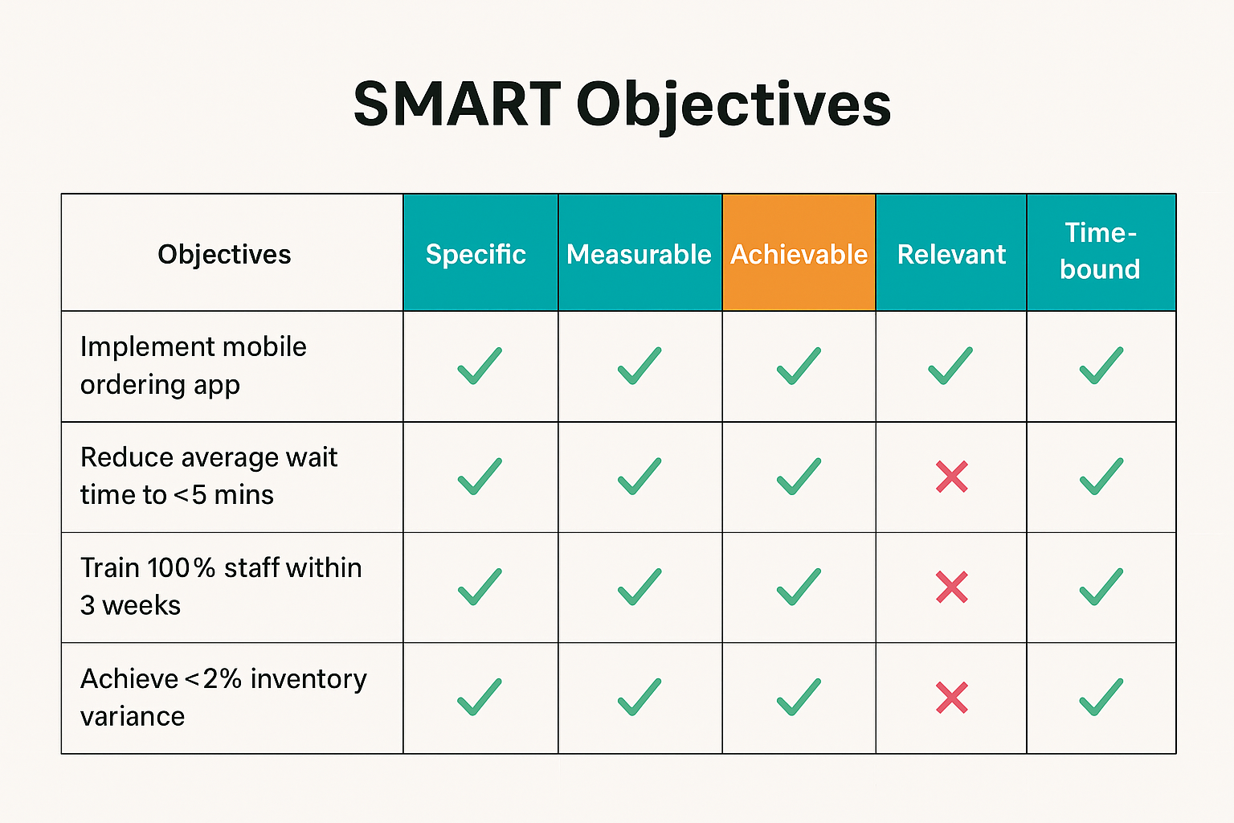

## 5.1 Objective Overview

**1. Implement mobile ordering app**  
This goal is clearly defined and aligned with the project vision, aiming to digitize the ordering process to reduce manual workload. It's fully measurable, trackable, and realistically achievable within the project timeline.

**2**. **Reduce average wait time to <5 mins**  
The objective targets operational efficiency but is partially dependent on crowd behavior and adoption rates. While it's measurable and relevant, achieving it universally may require adaptive strategies.

**3. Train 100% staff within 3 weeks**  
This is a focused and time-bound goal that ensures all staff are equipped to handle the new systems. Its success can be monitored through training logs and evaluation tests.

**4. Achieve <2% inventory variance**  
This objective supports operational accuracy but may not be immediately attainable due to system calibration and early usage issues. It is important but should be monitored over time rather than fixed to a deadline.

## 5.2 Key Deliverables

| **Category** | **Deliverable** | **Acceptance Criteria** |
| --- | --- | --- |
| Technology | POS Hardware (5 terminals) | Fully functional, integrated with app and payment gateway |
| App | Mobile ordering (iOS, Android) | Deployed on app stores, passes UAT |
| Inventory Management | RFID-enabled stock tracking | 98%+ accuracy in test environment |
| Training | SOP handbook, e-learning simulations | Reviewed and signed-off by Concessions Manager |
| Reporting | Live dashboard (KPIs, feedback) | Accessible via SDSU network, real-time data |

**1. POS Hardware (5 terminals)**  
This hardware upgrade enables faster, more reliable transactions at concession stands. Acceptance is confirmed when terminals are tested and fully integrated with the mobile app and payment system.

**2. Mobile ordering (iOS, Android)**  
The app facilitates pre-ordering and digital payments, reducing in-person queue times. It will be accepted once it's live on app stores and successfully passes User Acceptance Testing (UAT).

**3. RFID-enabled stock tracking**  
This system automates inventory tracking, improving accuracy and reducing manual errors. Acceptance requires at least 98% match between RFID logs and physical counts during testing.

**4. SOP handbook, e-learning simulations**  
Training materials ensure all staff are equipped to use new systems effectively. Deliverables are considered complete once approved by the Concessions Manager following review.

## 5.3 Scope Statement

| **Scope Category** | **Item** | **Purpose/Function** | **Owner** | **Impact on Project** |
| --- | --- | --- | --- | --- |
| **In-Scope** | Mobile app development and deployment | Enables digital ordering, reduces queue times | UX/UI Lead, Tech Lead | Core deliverable, high user impact |
|  | POS terminal integration | Digitizes payments and links to order system | Technical Lead | Required for real-time transactions |
|  | Staff training + media | Ensures smooth adoption, operational readiness | Training Lead | Reduces support burden post-launch |
|  | RFID tagging and real-time alerts | Automates stock monitoring and improves accuracy | Inventory Lead | Prevents overstocking and product shortages |
|  | Customer satisfaction tracking mechanisms | Collects real-time feedback to monitor app and service performance | Reporting/Analytics Team | Drives continuous improvement |

| **Out-of-Scope** | Staff hiring and payroll | Handled by existing SDSU HR channels | SDSU Concessions | No direct PM control; avoids HR entanglement |
| --- | --- | --- | --- | --- |
|  | SDSU-wide app integration | Broader initiative not part of pilot scope | SDSU IT/Strategic Programs | Keeps focus on pilot implementation |
|  | Arena-wide Wi-Fi upgrades | Involves separate infrastructure planning and budget | Facilities/IT | Mitigated by using mobile data fallback |
|  | Third-party food logistics | Managed through existing supplier contracts | Concession Vendors | Keeps vendor scope unchanged |

# 6. Project Schedule and Work Breakdown Structure (Expanded)

## 6.1 Project Timeline & Phases

| **Phase** | **Description** | **Duration** |
| --- | --- | --- |
| Planning & Requirements | Define scope, gather system requirements, stakeholder analysis | 2 weeks |
| System Design & Vendor Setup | UX/UI, system flow, select POS and RFID vendors | 3 weeks |
| Development & Integration | Develop app, install POS, configure RFID, test vendor API | 6 weeks |
| Staff Onboarding | Deliver training sessions, issue guides, test knowledge | 4 weeks |
| Testing & Feedback Loop | UAT testing with real orders, customer surveys, error logging | 4 weeks |
| Full Launch | Deploy at event, monitor performance, collect metrics | 1 week |

## 6.2 Work Breakdown Structure (WBS) and Gantt Chart

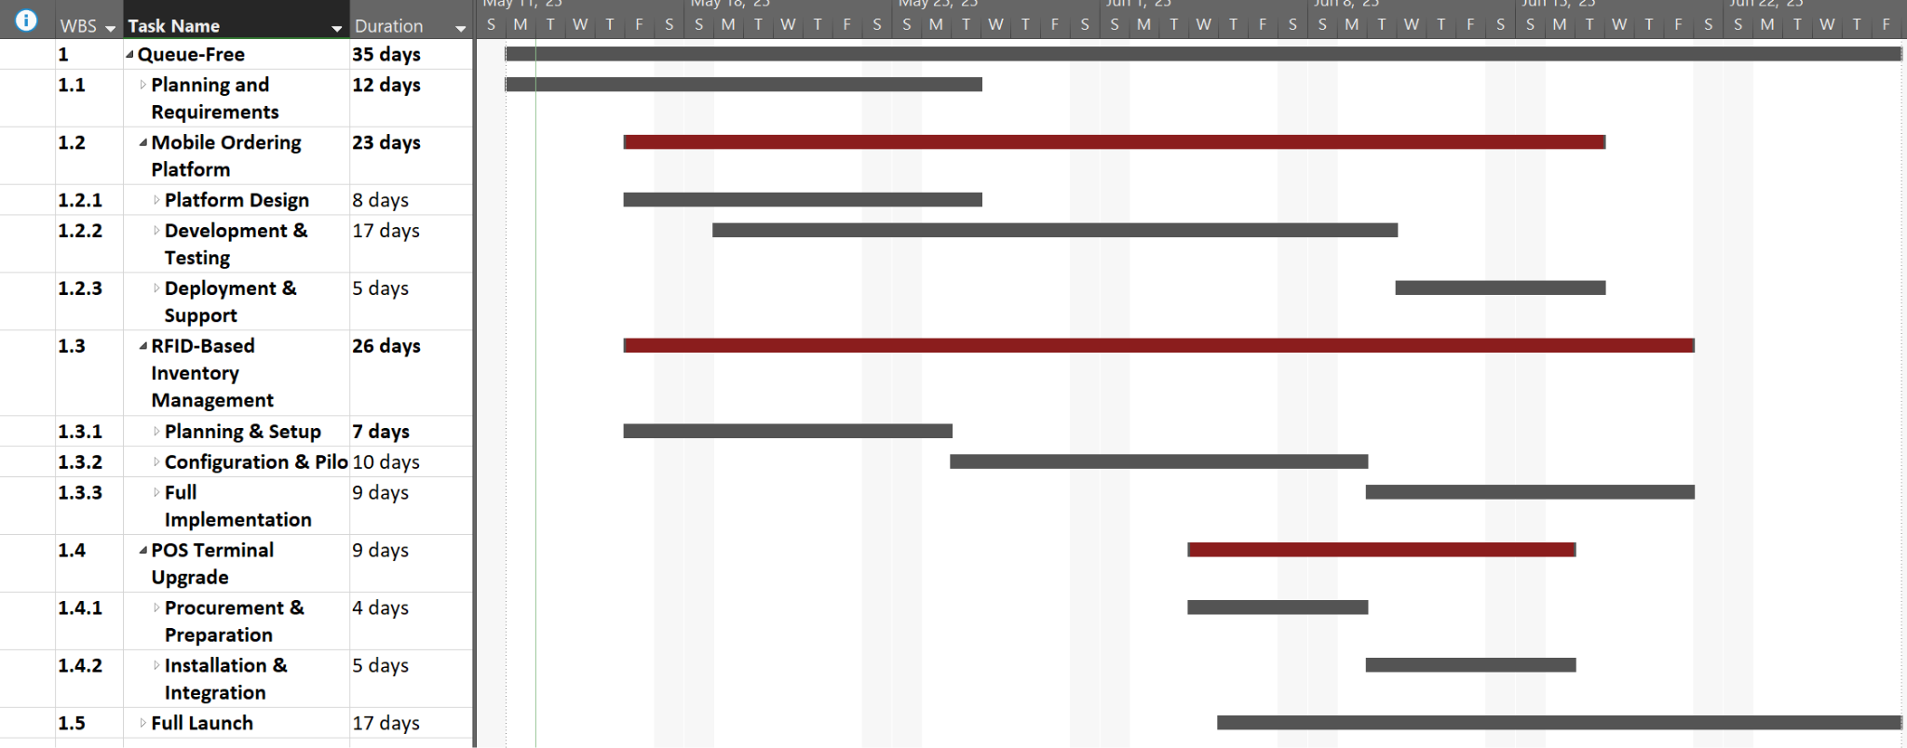

# 7. Budget

## 7.1 Budget Strategy

The Queue-Free project emphasizes technology innovation, staff readiness, and operational security. Budget allocation has been carefully estimated based on similar projects, supplier quotes, and SDSU concession projections. A contingency of 12% is built in for unforeseen changes.

## 7.2 Detailed Budget Table

| **Category** | **Subcategory** | **Description** | **Unit Cost** | **Qty** | **Total Cost** |
| --- | --- | --- | --- | --- | --- |
| **Digital Systems & POS** | POS Hardware | Touchscreen terminals for ordering | $3,000 | 5 | $15,000 |
|  | Mobile App Development | Custom app with live queue + vendor sync | - | - | $8,000 |
|  | Software Licensing | Annual POS & app middleware licenses | - | - | $7,000 |
| **Inventory System** | RFID Equipment | Tagging stations, label kits, backend configuration | - | - | $10,000 |
|  | Inventory Software Customization | Tailoring dashboards, alerts, and live sync tools | - | - | $8,000 |
|  | Vendor Integration Testing | API builds for supplier portals and syncing | - | - | $7,000 |
| **Staff Training** | Manuals and Guides | Printed & digital SOP documents | $50 | 60 | $3,000 |
|  | On-site Training Sessions | Trainer hours and logistics | $100/session | 70 | $7,000 |
|  | Simulation Software | Subscription for interactive roleplays | - | - | $5,000 |
| **Security Enhancements** | Surveillance Upgrades | Enhanced CCTV and motion-tracked POS monitoring | - | - | $3,000 |
|  | Fraud Detection AI | POS anomaly alerts and compliance reporting | - | - | $2,000 |
| **Contingency Reserve** | - | ~12% buffer for inflation, unexpected vendor/tech adjustments | - | - | $10,000 |

## 7.3 Summary Budget Breakdown

| **Main Category** | **Total Cost** |
| --- | --- |
| Digital Systems & POS | $30,000 |
| Inventory Management | $25,000 |
| Staff Training | $15,000 |
| Security Enhancements | $5,000 |
| Contingency Reserve | $10,000 |
| **Total** | **$85,000** |

## 7.4 Budget Notes

* POS system supports SDSU’s PCI-compliant infrastructure
* Internal app development reduces outsourcing cost by ~40%
* RFID system selected based on scalability and integration success in college arenas
* Ongoing costs (subscriptions, maintenance) managed by SDSU post-launch

# 8. Risk Management

Effective risk management is essential to anticipate, evaluate, and mitigate uncertainties that may impact project success. Our process aligns with PMBOK: **Identify → Assess → Respond → Monitor.** A preliminary risk register will be drafted through an all-hands brainstorming session with the stakeholders. We’ll pull in previous POS system update lessons learned from Aztec Shops and make use of expert judgement from the supporting implementation vendors. Marc Puno will serve as risk manager, leading the bi-weekly risk register review. Throughout project execution, risks and opportunities will be assessed, probabilities adjusted as more information is gathered, and mitigation / contingency plans will be executed as required.

## 8.1 Risk Categories & Examples

| **Risk Category** | **Description** | **Example** |
| --- | --- | --- |
| Technical | Failure in POS/App/Inventory integration | RFID not syncing live with vendor inventory |
| Operational | Staff or vendor unavailability | Trainers unavailable during onboarding |
| Financial | Unplanned cost escalations | Surge pricing from vendors for RFID hardware |
| Compliance/Legal | Regulatory non-conformance | Violation of health code due to new food processes |
| Adoption/User Risk | Poor app usage or tech resistance | Staff prefer manual transactions over mobile app |

## 8.2 Risk Matrix and Response Plan

| **Risk** | **Probability Score (1–5)** | **Impact Score (1–5)** | **Risk Score** | **Mitigation Strategy** |
| --- | --- | --- | --- | --- |
| POS or RFID integration failure | 2 (40%) | 3 | 6 | Begin integration 4 weeks early, sandbox testing |
| Staff resistance to digital tools | 3 (60%) | 2 | 6 | Incentivize completion of training, provide 1:1 support |
| Vendor delays in hardware delivery | 2 (40%) | 3 | 6 | Identify backup supplier, pre-order components |
| App crashing on event day | 1 (20%) | 3 | 3 | Simulate full load testing, maintain rollback-ready version |
| Budget overrun | 2 (40%) | 2 | 4 | Weekly budget review, activate contingency funds if >10% over |

# 9. Quality Management

Quality management ensures that all project deliverables meet the functional, operational, and usability expectations of SDSU and its concession customers.

## 9.1 Quality Goals

| **Deliverable** | **Quality Metric** | **Target** |
| --- | --- | --- |
| Mobile App | Crash-free usage, UX rating in pilot | <2 crashes/day, 4.5/5 |
| POS Terminals | Accuracy in payment processing | 100% transactions logged |
| Inventory System | Sync latency and stock accuracy | <10 sec lag, >98% match |
| Training Program | Staff performance score post-training | >90% test pass rate |

## 9.2 Quality Assurance Activities

* **Peer Reviews**: All technical components reviewed by internal leads
* **UAT (User Acceptance Testing)**: With 20 selected attendees and staff
* **Live Simulation**: Conducted during mock event
* **Feedback Surveys**: Collected post-training and post-launch

# 10. Procurement Management

Our proposed procurement strategy leverages existing SDSU vendor relationships and infrastructure where applicable. For POS and RFID system hardware and services, a short list of service providers will be drafted based on multiple criteria: cost, value, proximity, credibility, quality, etc. Requests for Proposal will be sent out during the planning phase and service providers will be assessed, ranked, and chosen based on this set of criteria. The provided cost estimates will serve as inputs to our project budget. Because our desired procurement requirements are clearly defined, we will use Firm Fixed Price (FFP) contracts to reduce SDSU’s risk and to ensure that vendors work efficiently and within scope of our project.

Integrated app will be developed in-house by the mobile dev team. Internal technical data will make use of vendor documentation, tailored and modified by our vendor coordination team. This includes setup, operation, maintenance, troubleshooting, and operational checkout documentation. Once complete, digital and paper documents will be published internally by Montezuma Publishing (Aztec Shops). All procurement contracts will be closed upon completion and acceptance of their corresponding deliverables and payment is routed.

# 11. Configuration Management

## 11.1 Overview

Configuration management will be implemented throughout project execution, monitoring, and controlling to ensure consistency and traceability of technical integration. The Configuration Manager (CM) will (1) maintain the configuration item register (CIR), plan the bi-weekly Change Control Board (CCB) agenda, moderate the CCB with relevant stakeholders, facilitate project-wide impact of changes, and communicate change status across the organization. Any individual member of the project team may submit a change request and it will be assessed by the CCB for potential impacts and concurrence. This includes the mobile application, RFID firmware hardware and integration, and POS software with existing and new terminals. We anticipate minimal changes throughout the project life cycle, Google Drive will be the tool for submission and configuration controls.

## 11.2 Change Control Board

**Configuration Manager:** Deshik Patel

**Members:**

* Manaswini Gopala
* Tejas Desai
* Sandesh Raut
* Marc Puno
* Supporting vendors and SubK

**Frequency:** Bi-weekly (reduced frequency based on change volume)

# 12. Monitoring, Reporting, and Communication

Project monitoring includes real-time tracking of schedule, budget, and deliverables using standardized templates and tools (e.g., Google Sheets, Trello, Slack). Meeting minutes will serve as summary documentation to ensure relevant project team members are still working within scope, schedule, and cost of our initiatives. The corresponding team lead for each facet of the project will identify upcoming action items, the responsible parties, and desired date of completion for their follow-up tasks.

## 12.1 Reporting Schedule

| **Stakeholder** | **Frequency** | **Medium** | **Deliverables** |
| --- | --- | --- | --- |
| Executive Sponsor | Biweekly | Zoom, Email | Milestone report, risk register, budget status |
| SDSU Concessions Dept. | Weekly | In-person | Dashboard walkthrough, training reports |
| Team Members | Weekly (Fri) | Slack, Google Meet | Sprint updates, blockers, task progress |
| Technology Vendors | Biweekly | Email, Zoom | Integration testing logs, delivery timeline |
| All Project Stakeholders | Monthly | Zoom webinar + meeting minutes | Full project status, schedule and cost progress, open action items and risks/opportunities |

## 12.2 Tools Used

* **Slack**: Daily standups and asynchronous updates
* **Google Drive**: Document repository
* **Trello**: Task assignments and progress tracking
* **Google Meet**: Formal reviews and status meetings
* **SurveyMonkey**: Customer feedback post-deployment

# 13. Conclusion

The Queue-Free initiative brings SDSU one step closer to a fully digital, frictionless stadium experience. By combining modern digital tools with thoughtful change management, this project addresses long-standing operational inefficiencies and repositions the university as a leader in smart event management. Each aspect of this plan, from stakeholder alignment and budgeting to risk mitigation and communication, is designed to ensure seamless execution and long-term sustainability.

The project is scheduled to complete by **August 31, 2025**, just in time for SDSU’s next athletic season. With team-wide commitment and structured management, success is within reach.

# 14. References

* Square POS Systems for Concessions: <https://squareup.com>
* RFID in Stadium Logistics: <https://www.impinj.com>
* Mastercard Contactless Survey: https://mastercard.com/insights
* FDA Food Safety Regulations: <https://www.fda.gov/food>
* Training Best Practices for Digital Tools: <https://ecisolutions.com>
* NSF International Standards for Food Safety: <https://www.nsf.org/>

# 15. Appendix

## 15.1 RACI Matrix

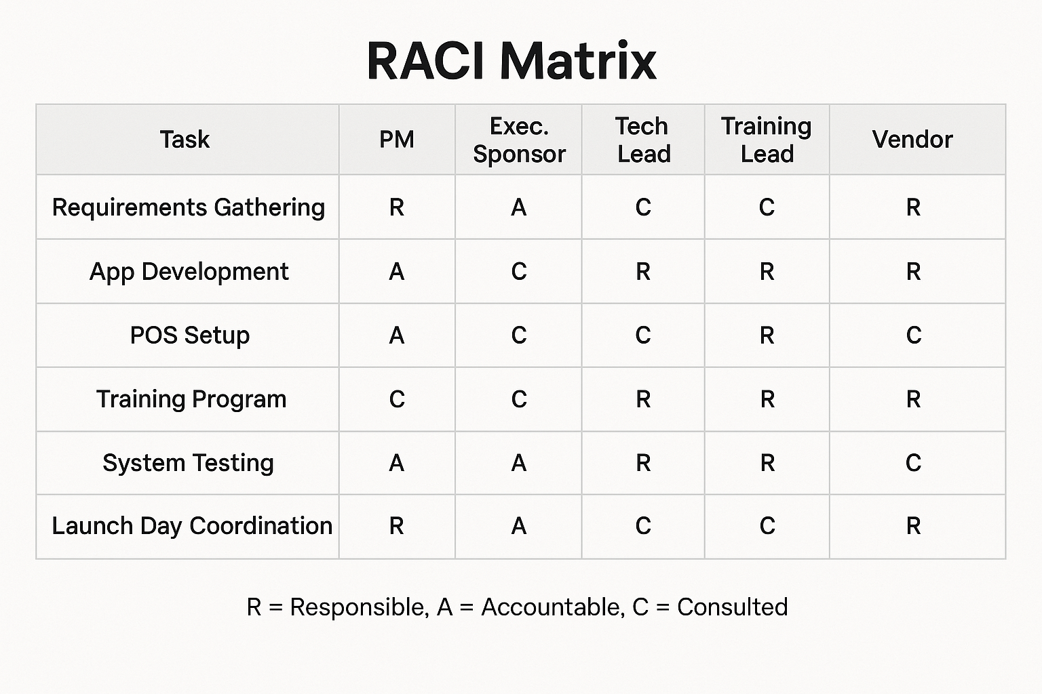

## 15.2 Selection Matrix (Digital Platform Options)

